Ai Lab 03
2026
1. Password Strength Checker Create a password strength checker that returns True if: o Length is at least 8 characters o Contains at least one uppercase letter o Contains at least one digit o Contains at least one special character (!@#$%^&*)
Solution:
Password="Iba@2026"

StrengthChecker = (len(Password)>=8 and
any(char.isupper() for char in Password) and
any(char.isdigit() for char in Password) and
any(not char.isalnum() for char in Password)
)

print(f"Valid Password: {StrengthChecker}")

Output:
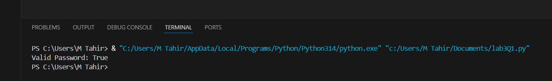

2. Eligibility Checker
Write a program that checks if a person is eligible for a loan based on: o Age ≥ 21 o Annual income ≥ 300,000 o Credit score ≥ 650 o No active bankruptcies Return True if eligible, False otherwise.
Solution:
Age =23
Annual_income= 350000
Credit_score= 700
Bankrupcy = False

isEligible = Age>21 and Annual_income>300000 and Credit_score>650 and Bankrupcy== False

print(f"IsEligible: {isEligible}")
Output:
